Step 1 create a report in IEX under “Conformance by Interval”
Step 2 Follow the setting in this report shown the screenshot below.
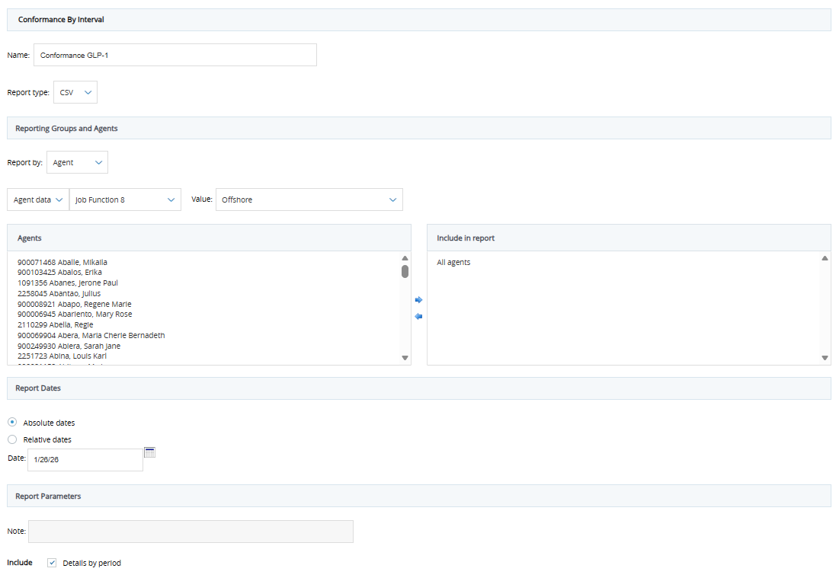
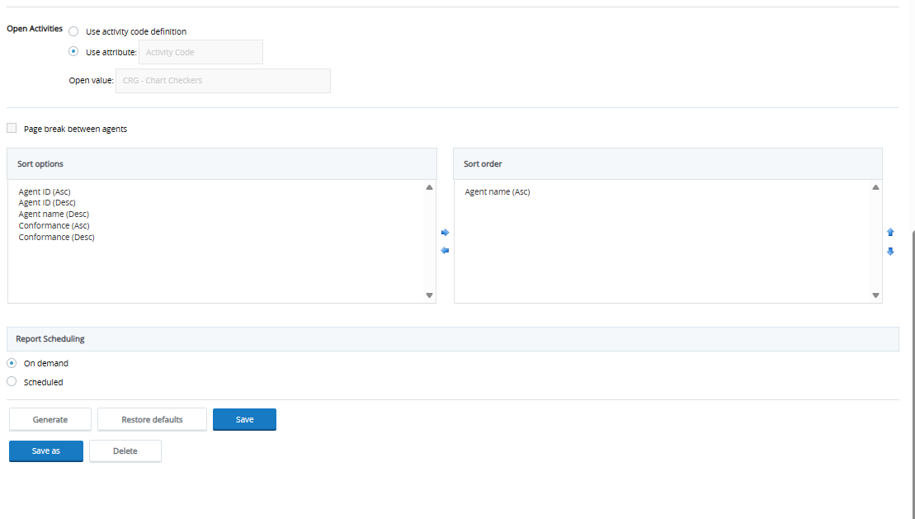
Note: under “Open activities” section select use attributes as “Activity Code” and under “open Value” select the activity code of the ancillary team you’re supporting E.g for GLP1 (CRG – Chart Checker)
Step 3. Save the report

Step 4. Whenever you ran the report just update the date to the current date and trigger the Open activities section by clicking the “Use activity code definition” radio button and clicking back the “Use attribute” radio button so it won’t be grayed out.

Step 5. Generate report

Once generated, download the file and upload it to our interval staffing tool

